1. Sorting is a common method used for visualizing data in a form that makes it easier to comprehend the story the data is telling. It is your job to sort the months in the bar chart in the correct order, from January to December. This will make it easier to interpret the visual and look at amount changes over time.

Download and open the Sorting_Data.pbix from Canvas and store it in your local drive.

* Convert the ProductCategoryName Slicer from a list into a dropdown list and then resize.

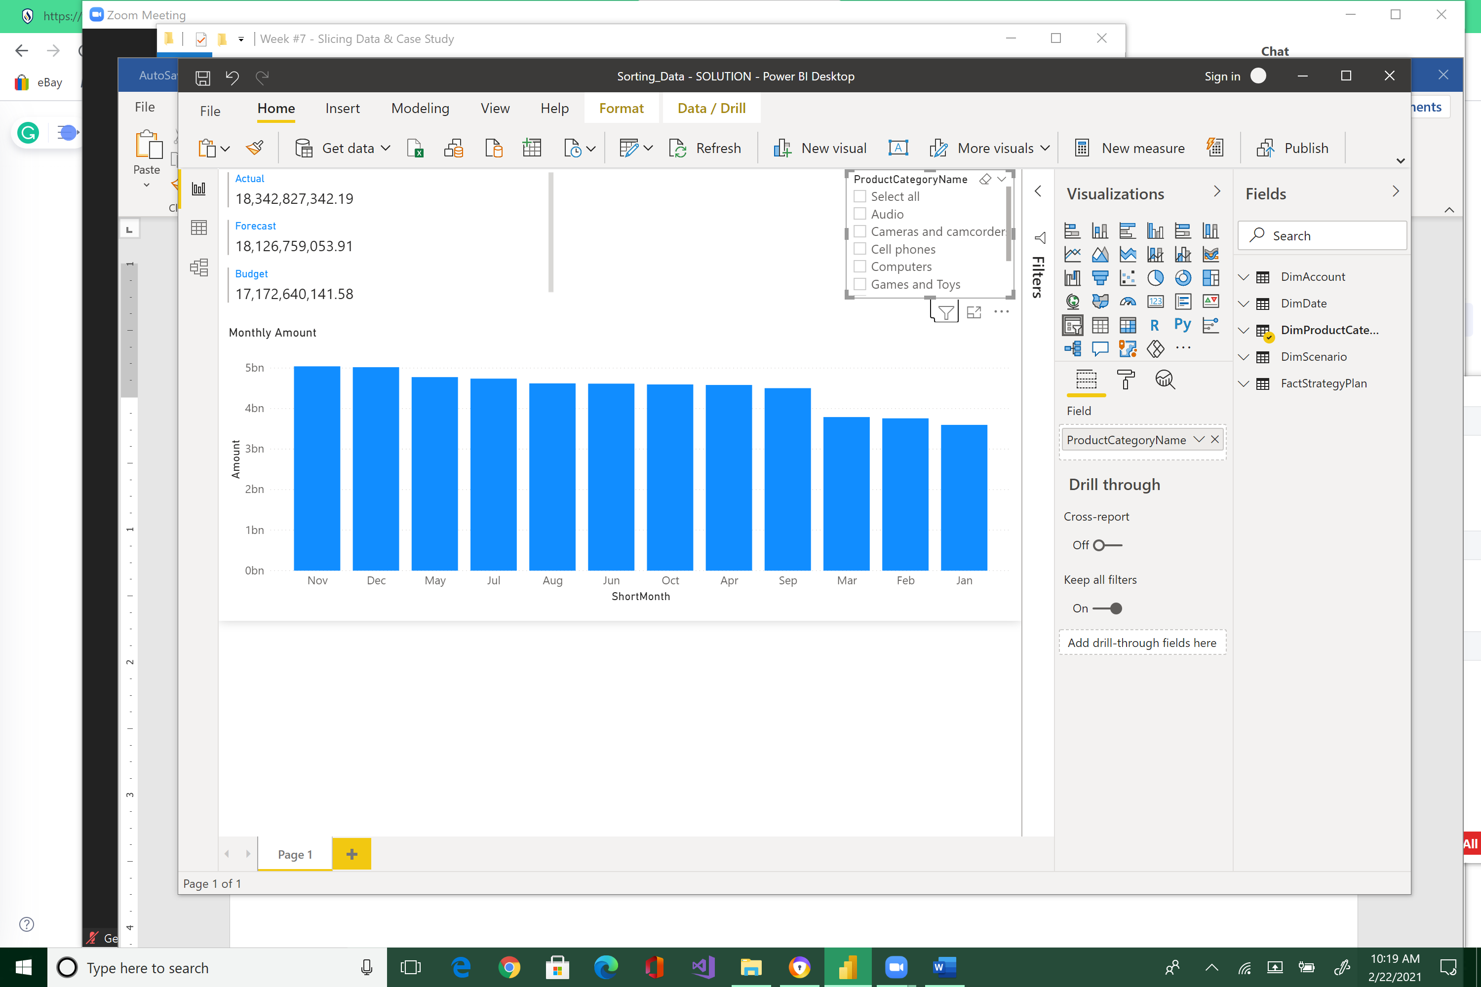 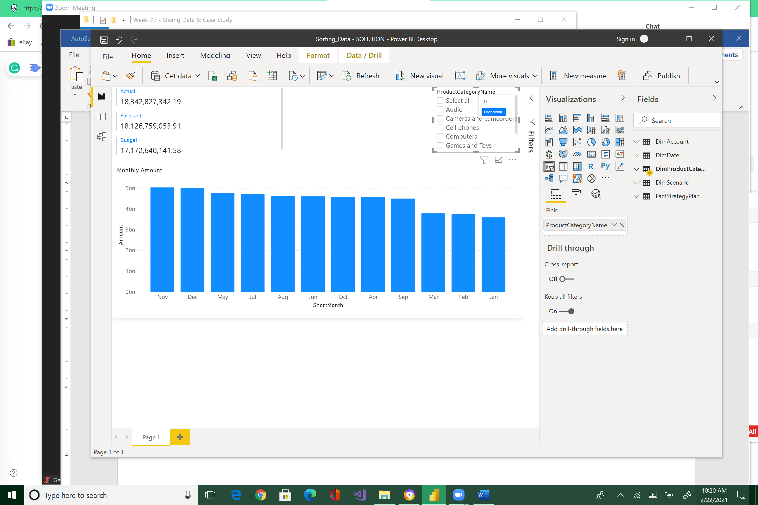 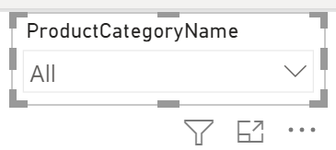



* Sort Monthly Amount Clustered column chart in ascending order.

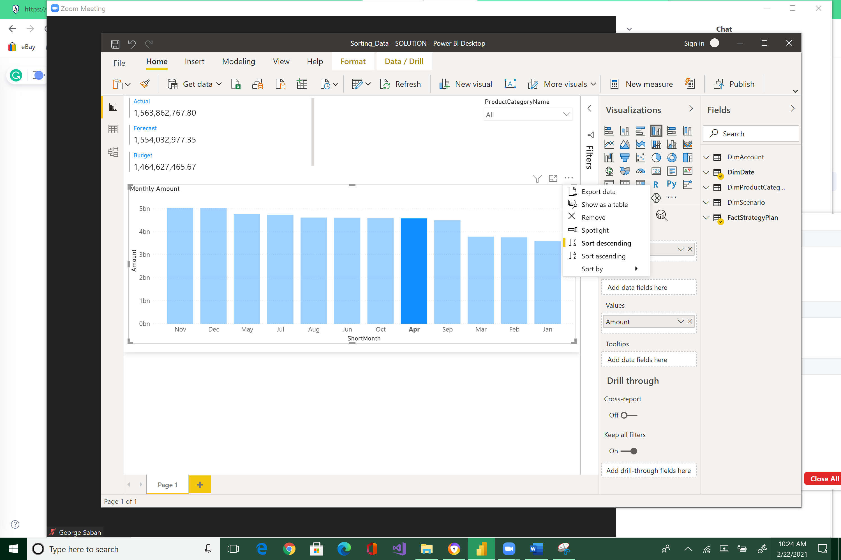



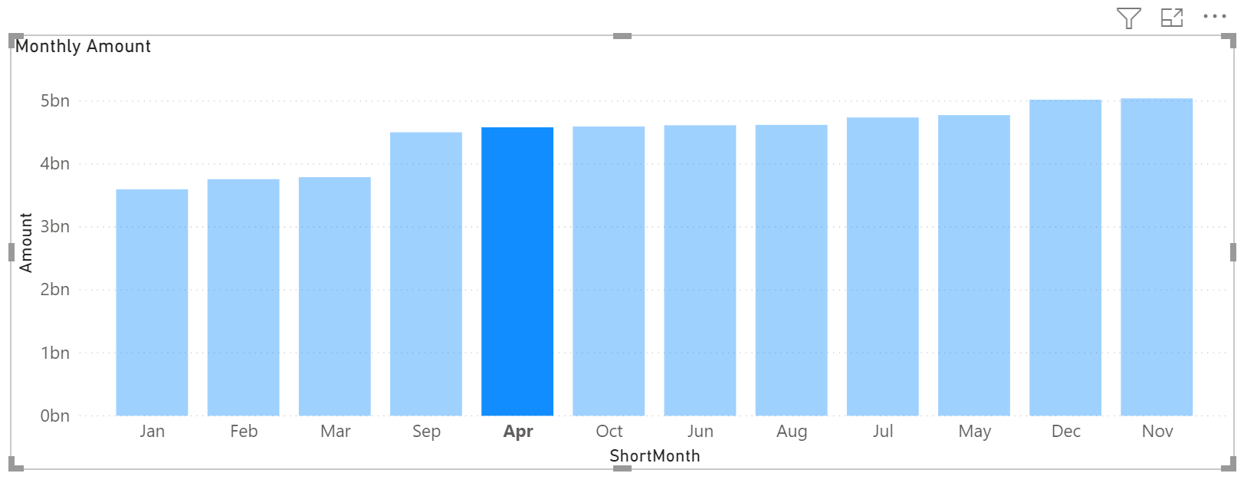

* Now sort it by descending order.

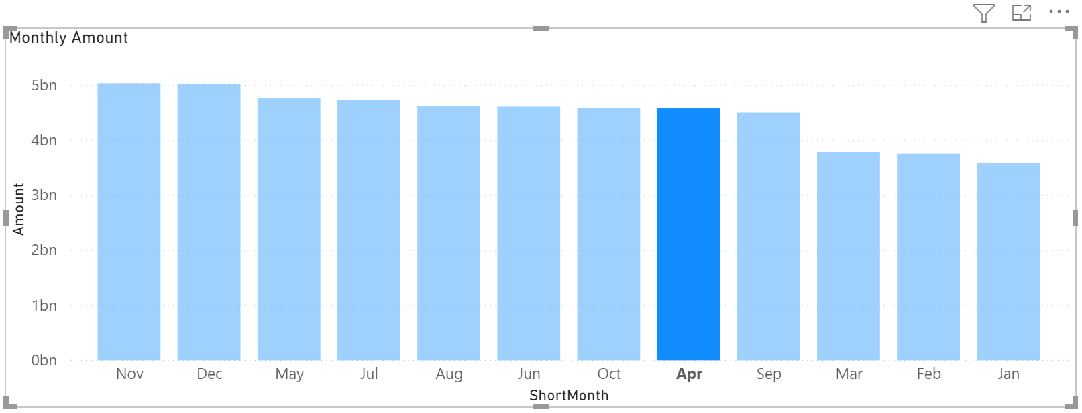

Note how the bars are sorted in alphabetical order by its month names, and not by the month’s numerical occurrence. Let us make some changes to the data to get the month sorting order fixed.

* Go to the *Data View* to make sure that ShortMonth in the DimDate table is ordered by MonthNumber. To do this, highlight MonthNumber column.

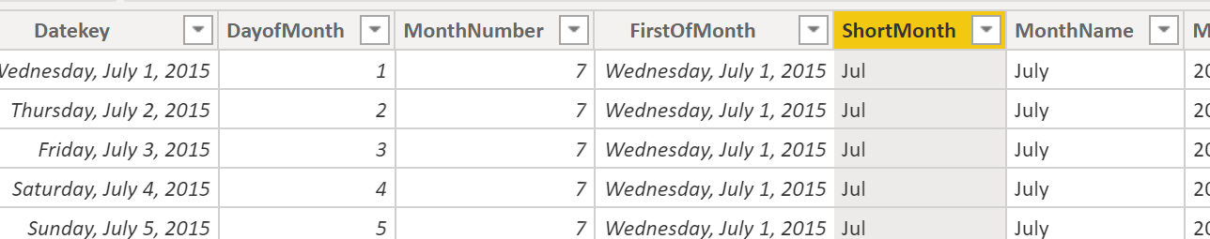



* Note that the contextual menu above changes, and there is now an option to sort a field based on the content of another column. In your case, you want to sort ShortMonth by MonthNumber.

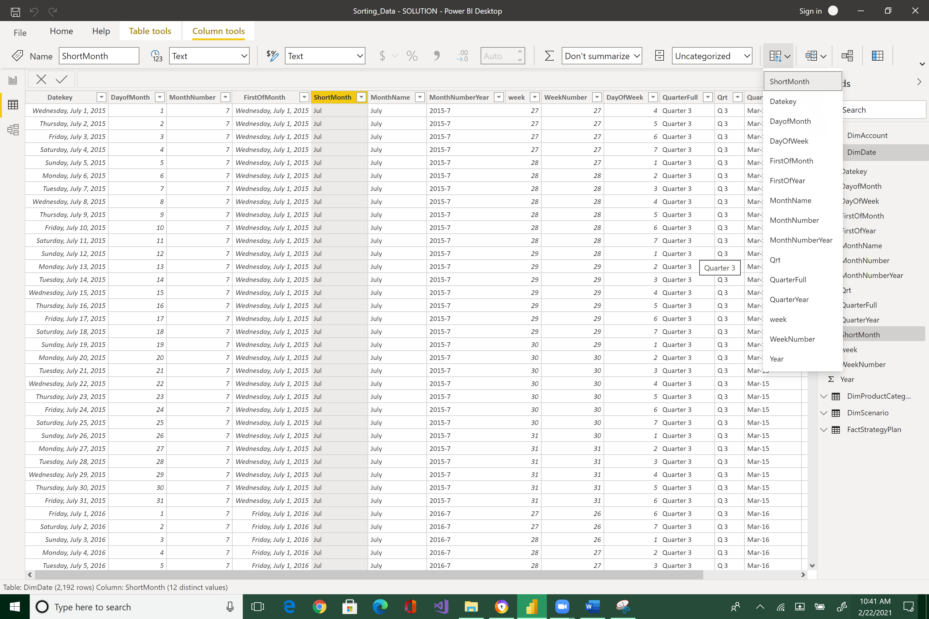



* Now, go back to the Report view. Sort Monthly Amount Clustered column chart in descending order: click the ellipses (…) > Sort by > ShortMonth.

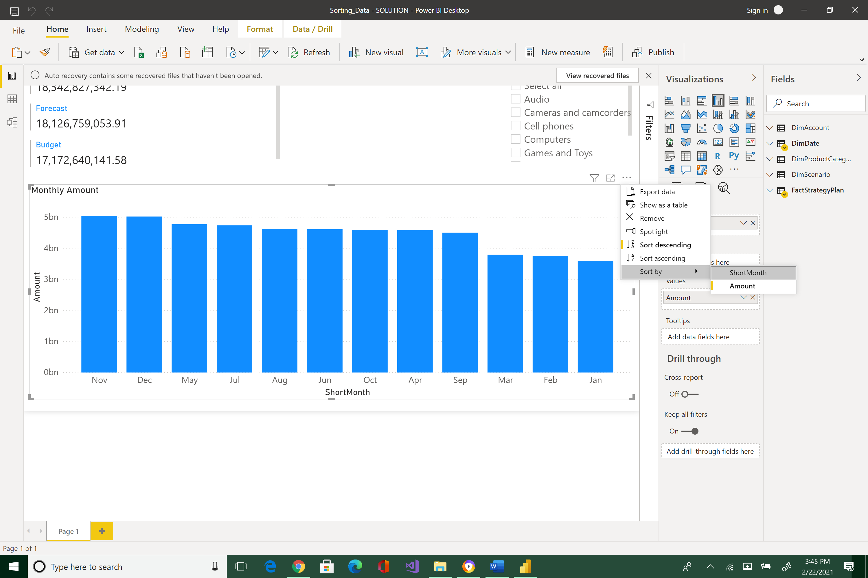



Call “Sort by” twice and note how the months are collated correctly.

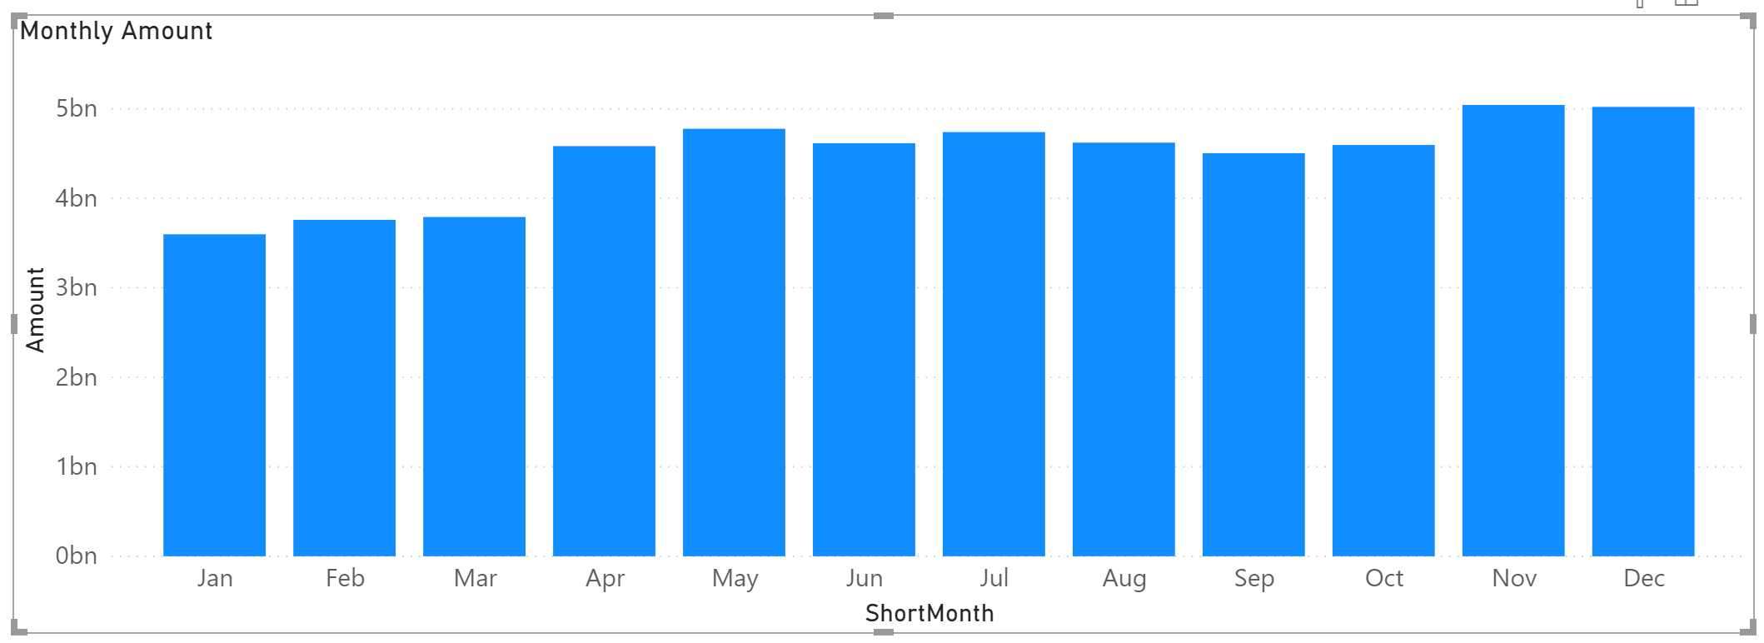

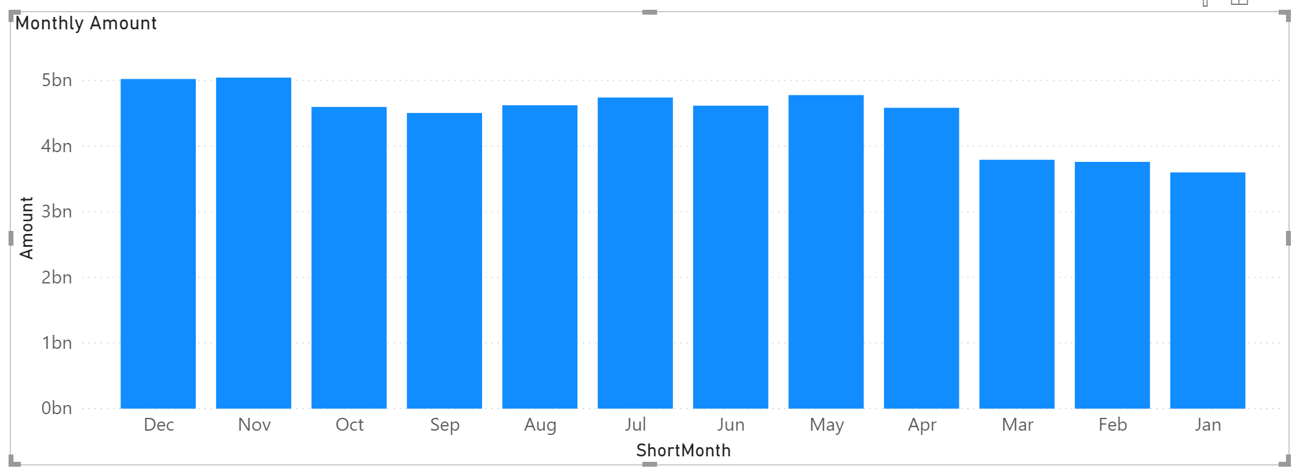

* Play around with sort in ascending and descending order by ShortMonth, and make sure the month names are arranged in the correct order.
* **How is the sales amount evolving throughout the year?**

**Possible Answers:**

* 1. **There is a downwards trend.**
  2. **There is an upwards trend.**
  3. **The amount stays the same.**

|  |
| --- |
| **B) There is an upwards trend.** |

#### 2.) Making it look good - Before your report is ready to share with other users, it is worth taking a final pass and making sure everything is looking great. In this exercise, you will format the report by changing the background color and making sure every visual has an appropriate size.

* Change the theme of the report to the *Innovate* theme. To do this, navigate to the View menu > Themes > Innovate theme

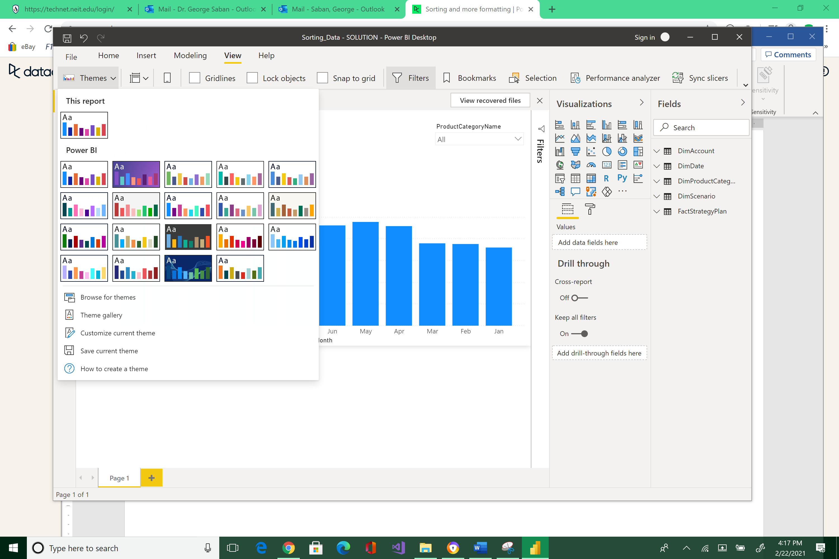



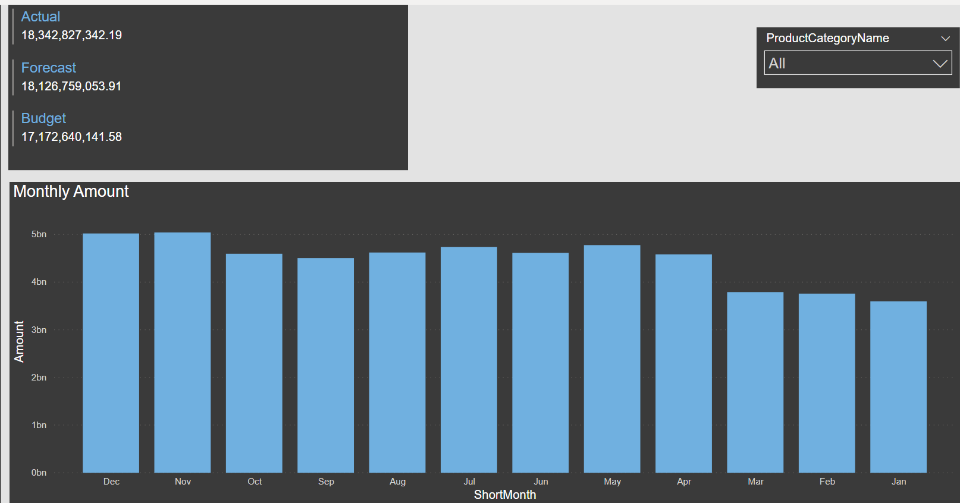

* Adjust the height of the dropdown box to be the same as the multi-row card.

**Next page >>>**

Please reposition your Report so that it would look like the image below. Take a snapshot using Window's Snipping Tool. Make sure the encircled items are included. Place your image at the end of this document (after the example below) and submit this completed artifact to Canvas in Word format.  Thank you!

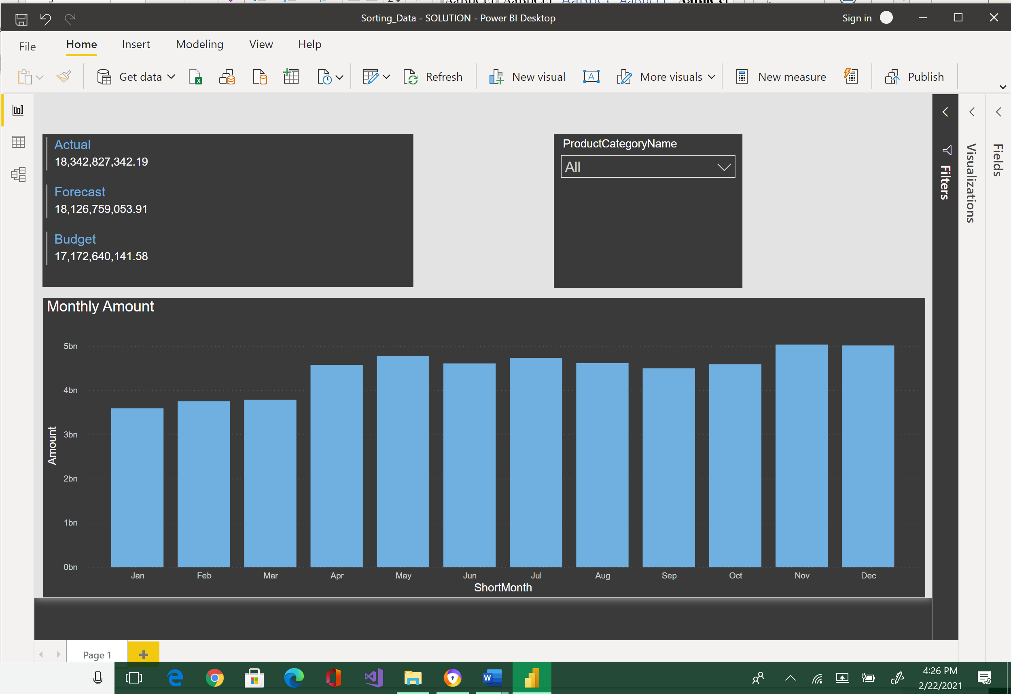



|  |
| --- |
| Please paste here your final image. |